Name: ________________________ Class:_______ Score:________
Resources Allowed: Calculator, 1 page of notes (A4 two-sided), Formula sheet

Time: 60 mins Marks: 57

- [3, 2 = 5 marks]
In reference to the following graph

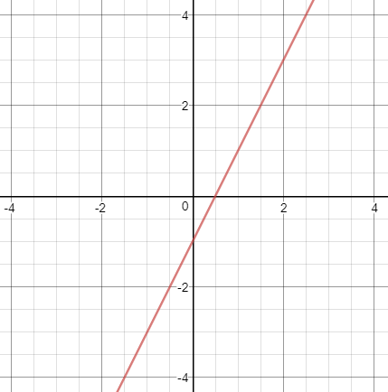

- State the;
i) gradient ii) y-intercept iii) x-intercept

- Write the equation for the line

- [2, 2, 3 = 7]

- On the given axes, graph the equation y = -2x + 1

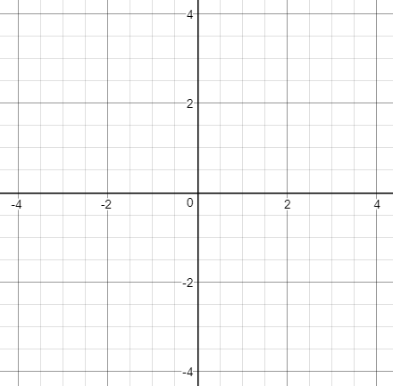

- Add a line that is parallel to the one graphed and label it with the correct equation.

- Add a line that is perpendicular to the original. What is the equation of the perpendicular line?

- [6 marks]

Colin invests $5000 for 5 years at 5.25% p.a. compounded quarterly. How much more has he collected at the end of the 5-year period than if the money had been invested at 5.25% simple interest for the same time period?

- [1, 2, 2, 2 = 7]

Factorise each expression.
(a) 15a² − 3a (b) 2x(a − 4) − 3(a − 4)

(c) x² – 9x + 18 (d) x² – 5x – 24

- [2, 2, 2 = 6 marks]

The graph y = x² has been for you on the graphs below:

- Plot the graph y = x² – 4

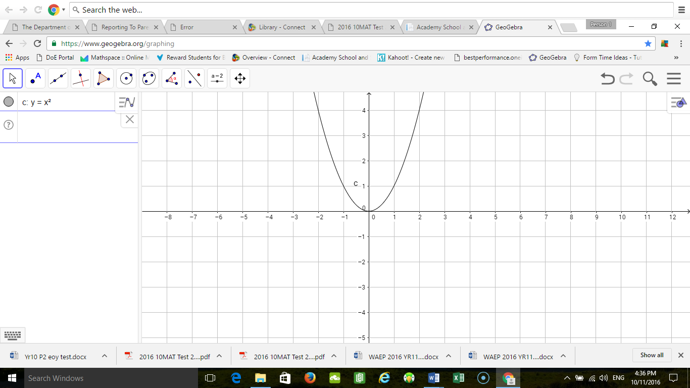

- y = (x - 2)²



- y = (x + 2)² – 3



THIS PAGE HAS BEEN LEFT BLANK INTENTIONALLY

- [3, 2 = 5 marks]

The coach of the under 16’s Baldivis Brumbies football team wanted to know if there was a correlation (relationship) between his players body fat and the number of kilometres they ran per week.

Players Body Fat | Kilometres Run per week
15% | 34
8% | 62
25% | 19
23% | 23
12% | 45
14% | 39
32% | 9
29% | 13
17% | 32
12% | 51
11% | 48
6% | 60
10% | 52
20% | 27
17% | 30
19% | 28
22% | 21
27% | 11
24% | 13

Plot the following information in a scatter plot with the appropriate labels on the axis.
- Draw a line of best fit (trend line)
- Comment on the relationship of the data

- [3, 3, 3 = 9 marks]
The following data represent the heights, measured in cm, of the players in a netball club.

149 158 172 164 160 172 180 175 160 159 161 173 170
181 179 168 155 149 150 160 172 161 178 159 162 165

(a) Find the five-figure summary and inter-quartile range for the data set.

Min.
Q₁
Median
Q₃
Max
IQR

(b) Draw a box plot of the data.

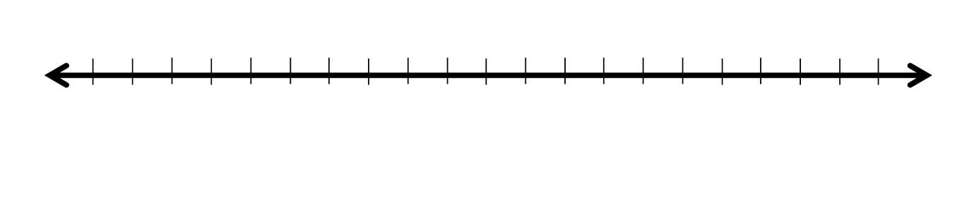

- What would be the cut-off values for outliers? Are there any outliers in the data set?

- [2, 2, 2, 2, 2, 2 = 12 marks]

A farmer has 240 m of fencing to make a rectangular paddock.
(a) Complete the table.

Width (W) | 20 | 40 | 60 | 80 | 100 | 120
Length (L)
Area (A)

(b) Find the formula for the area of the paddock, using only A for the area and w for the width.

(c) Sketch the graph of the function for values of w up to and including 120 m.

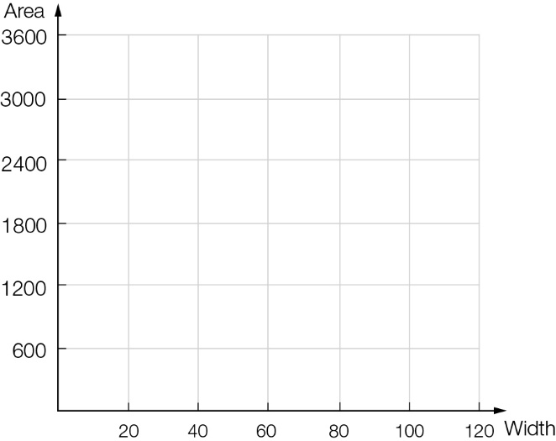

(d) What length and width give the greatest area?

(e) Now repeat this for a farmer who has 400 m of fencing available.

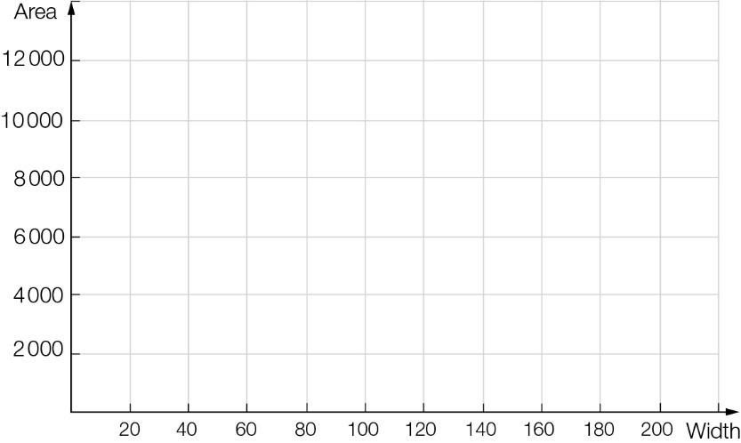

(f) What general conclusion might you reach from these two examples?

End of Test

